ASSIGNMENT 1
Data Analytics and Visualisation

AWS Honeypot Data: Visualising the Threat of Cyberattacks

INTRODUCTION

This report describes the insights/patterns drawn out of the chosen dataset which is “AWS Honeypot Data”. To begin with let’s understand what cyberattacks is. According to digital industry experts a cyberattack is an attempt to gain unauthorised access to any asset or data in order to expose, alter, disable, destroy, steal, or make unauthorized use of them. A cyberattack is any type of offensive maneuver that targets computer information systems, computer networks, infrastructures, or personal computer devices, it can be initiated by nation-states, individuals, hackers, groups or organisations. [1]
Cyber-crime and attacks are increasing day by day and is a new norm now a days. IT Governance discovered 1,243 security incidents in 2021, which accounted for 5,126,930,507 breached records. That represents an 11% increase in security incidents compared to 2020 (1,120).
By contrast, there was a significant decrease in the number of breached records over the same period (20.1 billion).
However, it’s worth noting that in most cases, the organisation doesn’t reveal the number of records involved, either because it doesn’t know or isn’t compelled to make the information public. As such, the true number of breached records will be considerably higher.[2]. (Answer to question a)
This visualisation report has Leaflet world map, Plotly for interactive graphs, timeline graphs, forecasting and comparison of attacks for day, months etc. which were a bit complex, interesting and took a lot of time. (Answer to question C and D)[3]

Theoretical considerations –
- Observable – Anyone can identify trends by looking at it.
- Original – Data is from verified source.
- Clear, concise and interactive graph with detailed information.
- Multivariate graphs to clearly identify relationships.
(Answer to question E)

What Can We Learn From Data About Honeypot Cyberattacks?

Visualisation focused on descriptive analysis and predictive analysis. We can identify the top countries and source (IP addresses) from which attacks originate, attack patterns and timing in terms of attack weeks, days, hours, and minutes. (Answer to question f)
Based on an open-source database from Kaggle that included information about cyberattack attempts, total of records of 451,581 attacks on AWS honeypots for a period of 6 months from 180 countries.
8 people in total published report on kaggle, and one observed on internet. (Answer to question B)
Kaggle link : https://www.kaggle.com/casimian2000/aws-honeypot-attack-data

Dataset description
Variable | Description | Type
Datetime | Time and date of attack | Character
host | Host name of honeyspot server | Character
src | Source of attack | Number
proto | Prototype Used (TCP/UDP/ICMP) | Character
type | Type of honeyspot | Number
spt | Source port | Number
dpt | Destination port | Number
srcstr | IP address of attacker | Character
cc | Country code | Character
country | Country where attacker pose to be | Character
locale | City | Character
localeabbr | City code | Character
postalcode | Unique Pin code of address | Character
latitude | Latitude | Number
longitude | Longitude | Number
X | Alternate value of latitude where latitude is wrong (>90 or <90) | Number

Data transformation and Cleaning
Dataset needed some transformation and cleaning, in terms of cleaning, only rows which did not have longitude and latitude were removed. Below is the list of features that were transformed.
- Converted datetime from character to POSIXct.
- Factored host, proto columns.
- Used tidyverse library function for factoring and categorising country and srcstr in group of top 10 and other.
- Sorted dataset by datetime column as the data was jumbled.
- Merged column X and latitude where latitude values were >90 and discarded column X.
- Segregated datetime into Year, Month, Day, Hour, Minute, Seconds columns.
Since the data transformation and cleaning is done let’s dig into the dataset and try to get insights by visualising dataset.
Plot 1 – Geolocations of the attacks
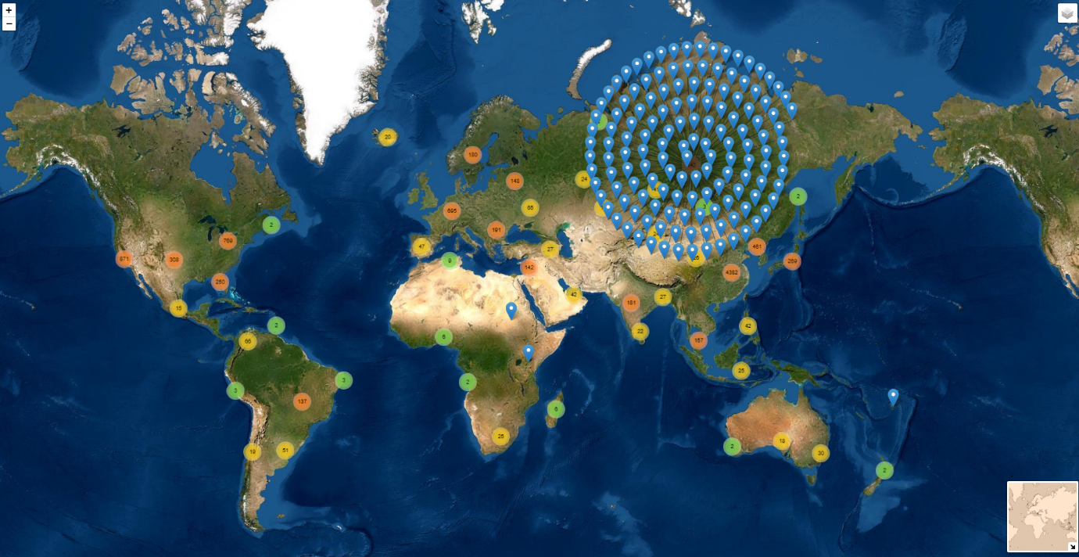

Above world map was gives a high level view of attacks and points out all the locations from where cyberattacks had been carried out. The map is built through an open source JavaScript library for interactive maps called Leaflet. Leaflet is a very powerful library with exceptional capabilities to work with locations, I have used few of them on this dataset, like colourful clusters which can be drilled down to see exact number of attacks and their location, and when hover over the pins a tooltip with host name, some other features included in it are mini-map at the bottom-right and ability to toggle map view at top-right of map.
Plot 2 – Box-Plot of attacks per day month wise
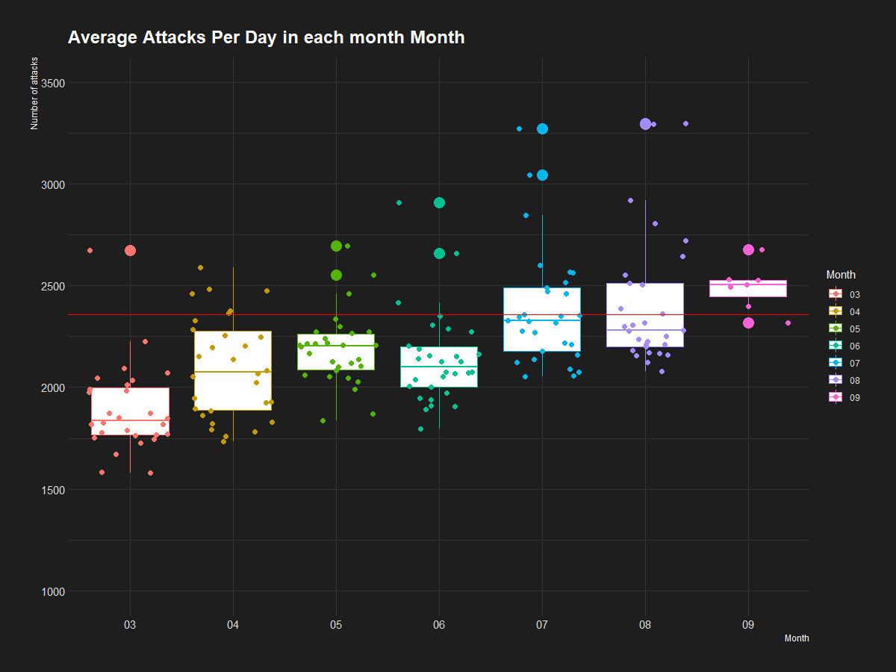

Above graph shows a box-plot to identify summary of attacks per day for the months March to September, with a horizontal line marking average number of attacks (2385) on one day for each month. One insight can be drawn from the above box-plot is that the attacks per day at the start of year are less than that of end of the year.

Plot 3 – Bar-Plot of attacks per month for countries with highest number of attacks.
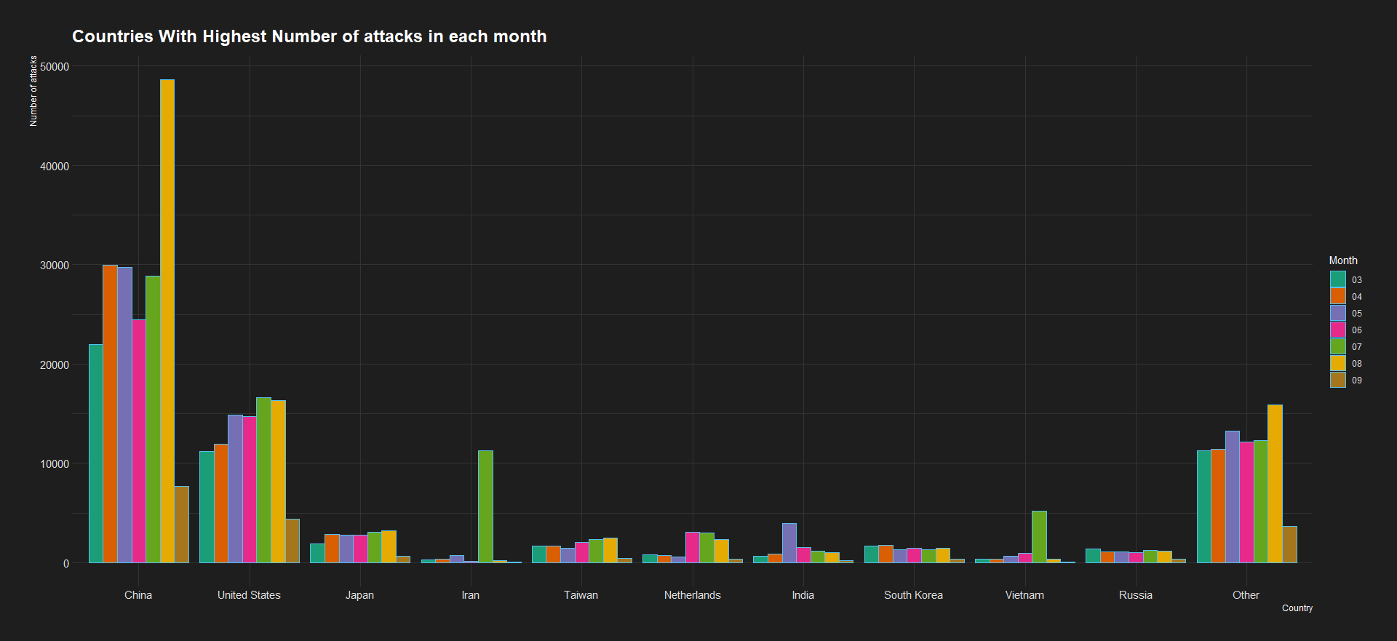
Above bar-plot displays the countries with highest number of attacks with coloured bars for each month. Above graph depicts a lot of information with top 10 countries and other as rest all countries with highest number of attacks ordered ascending from left to right with china on top and America on second position. It can be seen that over-all most of the attacks were carried out in August and September with some exception scenarios like in Iran and Vietnam where most of the attacks were in July Month.

Plot 4 – Timeline of attacks per day for every month

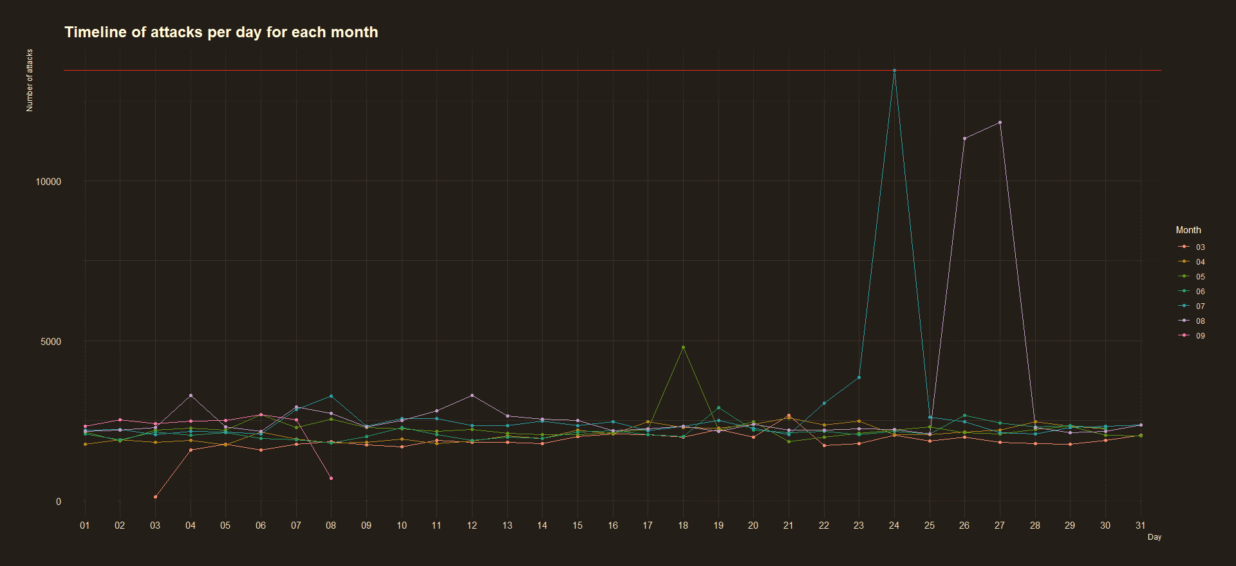
Above timeline graph shows the attacks occurred in each day for all the months. Almost all the days have equivalent attacks for all the month except a few cases. A red horizontal line marking the highest number of attack carried on a day, which depicts that 24th of July was the day with 13463 attacks which is the most carried in a day, 27th and 26th of August, 18th of May with second and third and fourth highest attacks in a day, whereas lowest on a day was noticed on 3rd of March and 8th of August which are the first and last day of attacks recorded in the dataset.

Plot 5 – Timeline of attacks per day for country wise
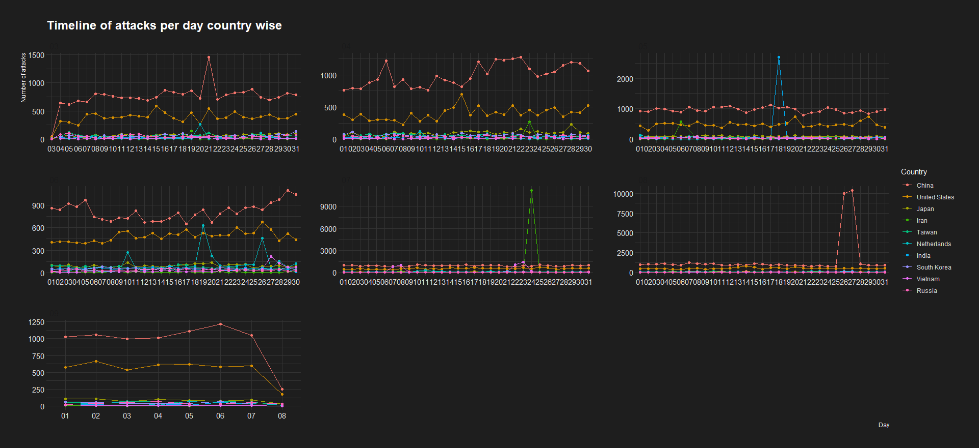

Above timeline graph tells us exactly the day and month in which the top 10 countries with highest number of attacks were at more risk or recorded attacks and also shows a trend of countries too. It’s clear that for July and August highest number of attacks were from Iran, China and India on 24th July and 26th, 27th of August and 18th of May respectively which we also saw in Plot 4. For rest of the month the pattern seems to be same with China and America with highest attacks throughout each day.
Plot 6 – Top 10 bad IP addresses and countries with highest attacks, their respective IP address and the months of attack
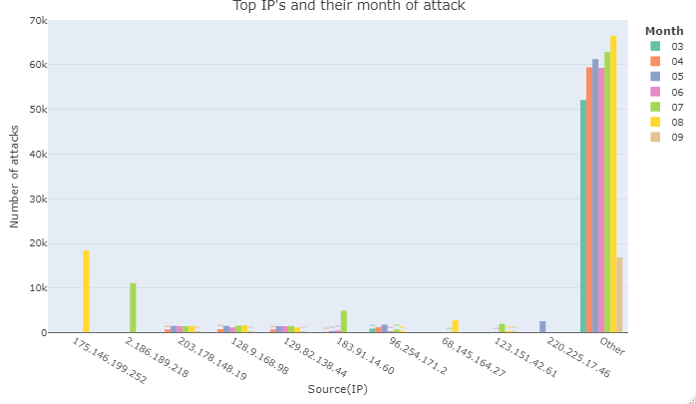
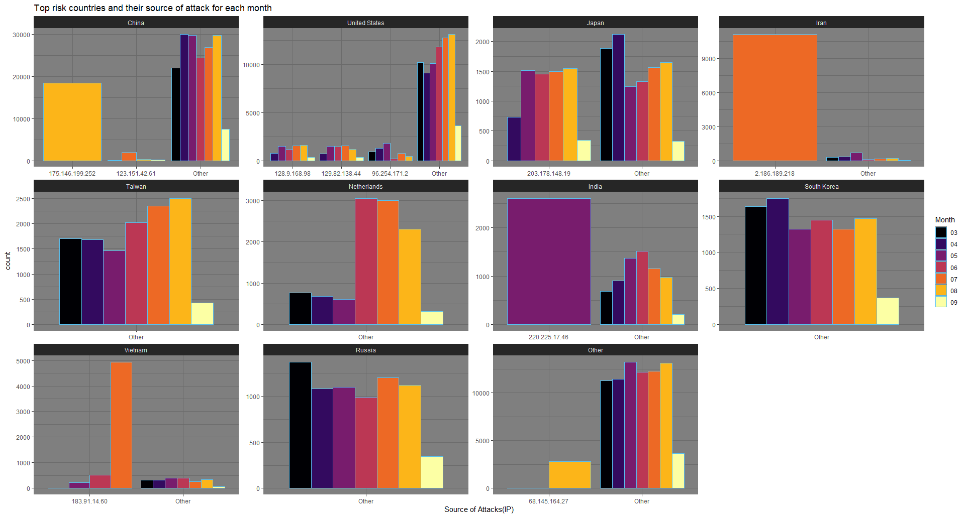

Above bar plot shows top 10 bad IP’s and the proportion of attacks from top IP’s in countries with respect to months.
- For China 19% of the attacks occurred from 175.146.199.252 only in the August.
- India recorded 2.8% of total from 220.225.17.46 in May.
- Iran has 11.8% attacks from 2.186.189.218 in July month, rest all attacks were from other IP addresses.
- Japan has 7.5% attacks from 203.178.148.19 in different months with least in September.
- Vietnam has 6% attacks from 183.91.14.50 with most in the month of July.
- Taiwan, South Korea, Russia and Netherlands recorded attacks from other IP’s.
- America Has 15.2% attacks from top IP addresses and rest from other IP’s, all in different months.
For the sake of clear representation percentage are not shown in this graph.
Plot 7 – Forecasting attacks in next 3 months

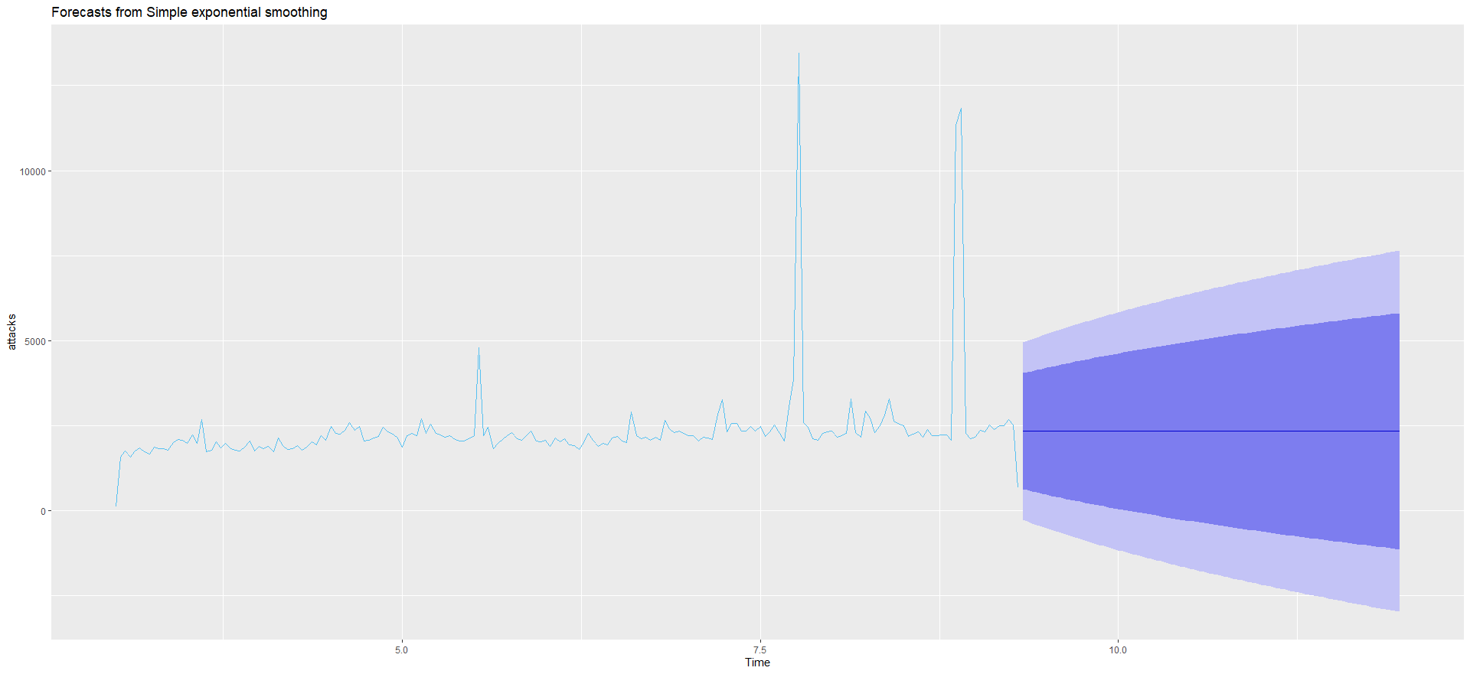
A linear trend in the attacks has been identified and thus the forecasting is showing constant attacks with 2340 attacks per day in the next 3 months with 95% confidence interval.

Main Findings:
- Most of the cyberattacks originate from China (191K attacks) and the U.S (90K attacks).
- On an average day, there were 2386 Cyberattacks on AWS that were diverted to the honeypot.
- Highest in a day was on July 24th (13463) and August 26th – 27th after it.
- Number of attacks remains consistent for next few months as forecasted.
Conclusion:
This report focused on attacks attempted on Amazon Wes Services (AWS), honeypot is an effective way combating the impact of cyberattack on computer infrastructure. A honeypot is a computer system intended to mimic likely targets of cyberattacks. It can be used to detect attacks or deflect them from a legitimate target. Above visualisation analysed information like most number of attacks originated from which countries and IP’s, trends and also forecasted future attacks, this combined insights and the tool itself can be a way to identify, prevent and lure attacker and guard precious assets. Given more time I could have explored more patterns in the attack timing day like per hour, minute. (Answer to question G)

References
[1] “Cyberattack,” Wikipedia. Feb. 27, 2022. Accessed: Mar. 05, 2022. [Online]. Available: https://en.wikipedia.org/w/index.php?title=Cyberattack&oldid=1074234744
[2] L. Irwin, “Data breaches and cyber attacks in 2021: 5.1 billion breached records,” IT Governance UK Blog, Jan. 20, 2022. https://www.itgovernance.co.uk/blog/data-breaches-and-cyber-attacks-in-2021-5-1-billion-breached-records (accessed Mar. 04, 2022).
[3] B. Walker, “Making Interactive Maps in R with Less Than 15 Lines of Code,” Medium, Nov. 29, 2019. https://towardsdatascience.com/making-interactive-maps-in-r-with-less-than-15-lines-of-code-bfd81f587e12 (accessed Mar. 05, 2022).

